Problem statement:

We want to estimate a patient outcome (let’s call it y) as a function of three variables: x1, x2, and x3. Let us assume that x1, x2, and y are continuous variables and x3 is binary. We are given data from several hundred patients to build a model that can estimate this outcome.

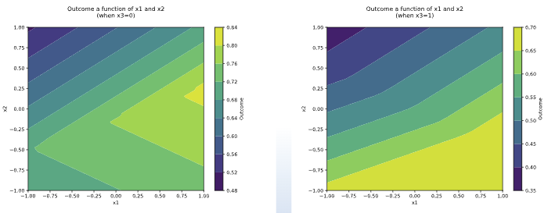

Question 1

Draw a feed-forward neural network with one hidden layer with two nodes that takes each input element (x1, x2, x3) and provides an outcome y=f(x1,x2,x3). Write its corresponding equation.

Use ReLU activation functions for the hidden nodes and the softplus function as the activation function for the outcome node.

𝑟𝑒𝑙𝑢𝑥=max(0,𝑥)

softplus𝑥=𝑙𝑜𝑔!(1+exp𝑥)

Input Layer | Hidden Layer | Output Layer

Hidden Layer Calculations:

* h1=relu(w11(1) x1+w21(1) x2+w31(1) x3+b1)
* h2=relu(w12(1) x1+w22(1) x2+w32(1) x3+b2)

where w11, w21, w31, w12, w22, are the weights for inputs x1, x2, x3 respectively, and b1, b2 are the bias term.

Output Layer Calculation:

* y=softplus(w1(2) h1+w2(2) h2+b3)

where w1, w2 are the weights for the hidden layer outputs h1, h2 respectively, and b3 is the bias term.

Final Equation:

* y=log(1+exp(w1(2) max(0, w11(1) x1+w21(1) x2+w31(1) x3+b1)+w2(2)⋅max(0, w12(1) x1+w22(1) x2+w32(1) x3+b2)+b3)

Question 2

Assume your Feed Forward Neural Network has been trained and its corresponding weights are:

X1 to h1: 0.1 = w11(1)

x1 to h2: 0.3 = w12(1)

x2 to h1: 0.2 = w21(1)

x2 to h2: 0.8 = w22(1)

X3 to h1: 0.3 = w31(1)

x3 to h2: 0.5 = w32(1)

And the optimal biases for the hidden nodes are:

For h1: 0.3 = b1

For h2: 0.1 = b2

Similarly, from the hidden nodes (h1, h2) to the output node (y) the optimal weights are:

h1 to y: 0.5 = w1(2)

h2 to y: -0.5 = w2(2)

And the optimal bias for the outcome node is: 0 = b3

Using this trained model, estimate the outcome for the points:

(x1, x2, x3) = (1,0,0)

h1 = 0.4; h2 = 0.4

y=softplus(0.5⋅0.4+(−0.5) 0.4+0) = softplus(0.2−0.2) = softplus(0)

= log!(1+exp0)

= log(2)≈0.69

(x1, x2, x3) = (0, 0, 1)

h1 = 0.6; h2 = 0.6

y = softplus(0) ≈ 0.69

(x1, x2, x3) = (-0.2, 0.3, 0)

h1 = 0.34; h2 = 0.28

y = softplus(0.5⋅0.34+(−0.5)⋅0.28+0)

= softplus(0.17−0.14)

= softplus(0.03)=log(1+e0.03)≈0.71

(round your answer to two decimal digits)